EE219: Project 1

Due on Jan. 29, 2018

Zeyu Zhang (505030513)
Yunchu Zhang (805030502)

Introduction
Statistical classification refers to the task of identifying a category, from a predefined set, to which a data point belongs, given a training data set with known category memberships. Classification differs from the task of clustering, which concerns grouping data points with no predefined category memberships, where the objective is to seek inherent structures in data with respect to suitable measures. Classification turns out as an essential element of data analysis, especially when dealing with a large amount of data. In this project, we look into different methods for classifying textual data.

Dataset and Problem Statement
In this project, we work with “20 Newsgroups” dataset. It is a collection of approximately 20,000 newsgroup documents, partitioned (nearly) evenly across 20 different newsgroups, each corresponding to a different topic.

For the purposes of this project we will be working with only 8 of the classes as shown in Table 1. Load the training and testing data for the following 8 subclasses of two major classes ‘Computer Technology’ and ‘Recreational activity’.
Table 1 Subclasses of ‘Computer technology’ and ‘Recreational activity’
Computer Technology | Recreational Activity
comp.graphics | rec.autos
comp.os.ms-windows.misc | rec.motorcycles
comp.sys.ibm.pc.hardware | rec.sport.baseball
comp.sys.mac.hardware | rec.sport.hockey

Part (a) plot a histogram of the number of training documents
In this problem, we use the fetch_20newsgroups dataset from sklearn package to plot the number of training documents per class. The histogram is shown as following:
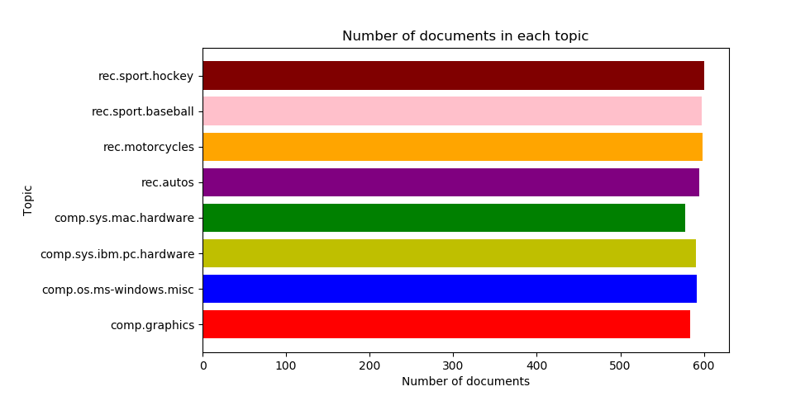
From the figure above, we could see that the data set is already balanced and in every class the number of documents is almost equivalent (balanced dataset).

Part (b) Create TFxIDF vector representation
A popular numerical statistic to capture the importance of a word is TFxIDF metric. This measure takes into account the words in the document. The discriminating words will most likely be those that are specialized terms describing different types of accessories and hence will occur in fewer documents.

In this problem, we need to convert the documents of 8 classes into numerical feature vectors. Firstly, we use ‘snowball’ to remove morphological affixes from words. After that, we remove all punctuation, all symbols and non-ascii characters. We used TfidfTransformer to calculate TFIDF, where tf(t, d) represents the frequency of term t in document d, and inverse document frequency is defined as: idf(t) = log [ n / df(t)] + 1 and df(t) is the document frequency; the document frequency is the number of documents that contain the term t.

When we set min_df = 2, the shape of the TFxIDF vector is (4732, 21795), which means the final number of terms is 21795. When we set min_df = 5, the shape of the TFxIDF vector is (4732, 8818), which means the final number of terms is 8818.

Part(c) Calculate the TFxICF
In order to quantify how significant a word is to a class, we calculate TFxICF. It is the same as TFxIDF, except that a class sits in place of a document; that is for a term t and a class c. And we need to find the 10 most significant terms in each of the 4 classes with respect to TFxICF measure.

The way we calculate the TFxICF is exactly as same as TFxIDF. This this part we treat each category as a huge document. We concatenate all the documents in the same category together to form a ‘large’ document, and this document represents the category. Here we have 20 categories, then we have 20 large documents. We then feed these 20 documents into the calcTFxIDF function, the output will be the TFxICF. The 10 most significant terms for each category is as following.
Table 2 Top 10 Significant Terms
comp.sys.ibm.pc.hardware | comp.sys.mac.hardware | misc.forsale | soc.religion.christian
scsi | edu | edu | god
drive | line | line | edu
edu | mac | sale | christian
ide | subject | subject | jesus
line | organization | organization | say
use | apple | new | church
com | use | post | subject
subject | quadra | com | people
organization | scsi | university | line
controller | problem | offer | know

dimensionality Reduction (LSI & NMF)
In this problem, we need to transform the data’s dimensional into a lower dimensional space. We use Latent Semantic Indexing (LSI) and NMF to lower the space into 50. As to LSI, we used the SVD decomposition to obtain left and right singular vectors and then get a lower space. We use Latent Semantic Indexing (LSI) to find the optimal representation of the data in a lower dimensional space. We use TruncatedSVD from sklearn’s decomposition package to decompose the vectors with 50 as the number of elements. Therefore, we get the selected features for our learning algorithms.
- Shape of feature vector after LSI: (4732, 50)
- Shape of feature vector after NMF: (4732, 50)

Linear Support Vector Machine
In next parts, we need to classify the documents into two categories ‘‘Computer Technology’ vs ‘Recreational Activity’. We need to combine documents of sub-classes of each class to form the set of documents for each class. And we need to assess the model by precision, recall and ROC curve. In this part, based on LSI and NMF, we used SVM to perform classification.

When min_df = 2
1) Hard-Margin SVM with LSI
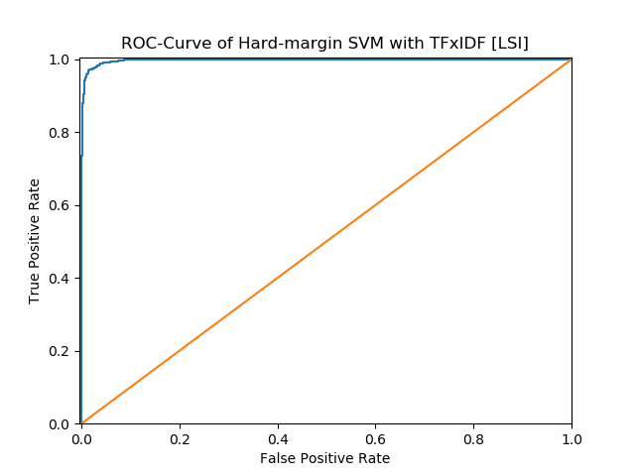

 | Precision | Recall | Accuracy
Computer technology | 0.9938 | 0.9295 | 0.9622
Recreational activity | 0.9349 | 0.9943 | 0.9622
Average | 0.9619 | 0.9644 | 0.9622

Confusion Matrix is as following (at Computer Technology row we treat Computer Technology as positive, vice versa):
 | TP | FP | FN | TN
Computer technology | 1450 | 9 | 110 | 1581
Recreational activity | 1581 | 110 | 9 | 1450

If We set computer technology as positive and recreational activity as negative to construct the confusion matrix as follow:
 | Ground Truth | Ground False
Predicted positive | 1450 | 9
Predicted negative | 110 | 1581

2) Hard-Margin SVM with NMF
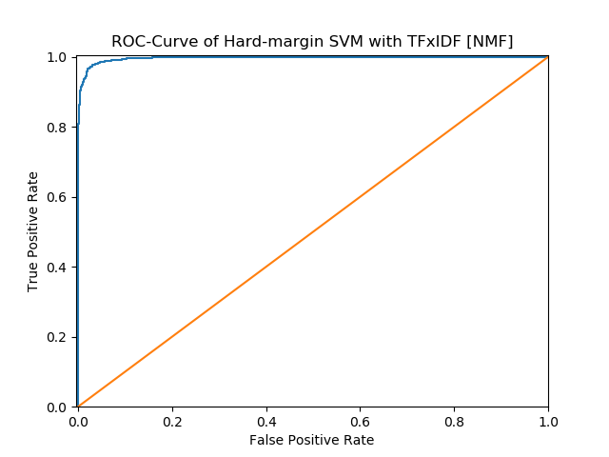

 | Precision | Recall | Accuracy
Computer technology | 0.9916 | 0.9090 | 0.9511
Recreational activity | 0.9174 | 0.9925 | 0.9511
Average | 0.9507 | 0.9545 | 0.9511

Confusion Matrix is as following (at Computer Technology row we treat Computer Technology as positive, vice versa):
 | TP | FP | FN | TN
Computer technology | 1418 | 12 | 142 | 1578
Recreational activity | 1578 | 142 | 12 | 1418

We set computer technology as positive and recreational activity as negative to construct the confusion matrix as follow:
 | Ground Truth | Ground False
Predicted positive | 1418 | 12
Predicted negative | 142 | 1578

3) Soft-Margin SVM with LSI
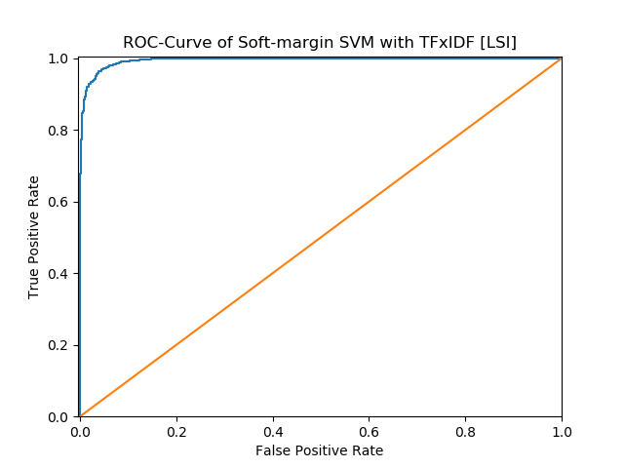

 | Precision | Recall | Accuracy
Computer technology | 0.9922 | 0.8917 | 0.9429
Recreational activity | 0.9033 | 0.9931 | 0.9429
Average | 0.9424 | 0.9477 | 0.9429

Confusion Matrix is as following (at Computer Technology row we treat Computer Technology as positive, vice versa):
 | TP | FP | FN | TN
Computer technology | 1391 | 11 | 169 | 1579
Recreational activity | 1579 | 169 | 11 | 1391

We set computer technology as positive and recreational activity as negative to construct the confusion matrix as follow:
 | Ground Truth | Ground False
Predicted positive | 1391 | 11
Predicted negative | 169 | 1579

4) Soft-Margin SVM with NMF
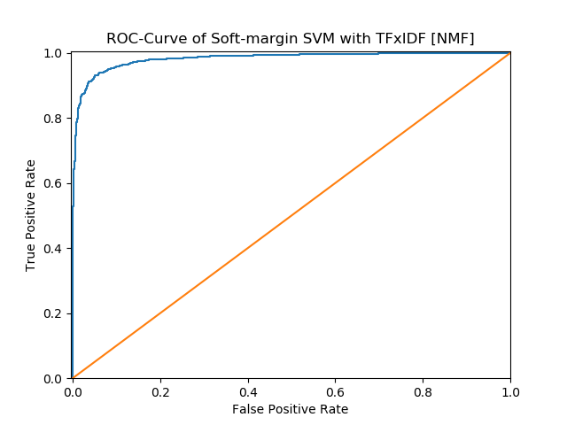

 | Precision | Recall | Accuracy
Computer technology | 1.0000 | 0.0410 | 0.5251
Recreational activity | 0.5152 | 1.0000 | 0.5251
Average | 0.5205 | 0.7576 | 0.5251

Confusion Matrix is as following (at Computer Technology row we treat Computer Technology as positive, vice versa):
 | TP | FP | FN | TN
Computer technology | 64 | 0 | 1496 | 1590
Recreational activity | 1590 | 1496 | 0 | 64

We set computer technology as positive and recreational activity as negative to construct the confusion matrix as follow:
 | Ground Truth | Ground False
Predicted positive | 64 | 0
Predicted negative | 1496 | 1590

For min_df=2, the LSI model is better then NMF and hard SVM is better than soft SVM.
When we set min_df=5
- Hard-Margin SVM with LSI
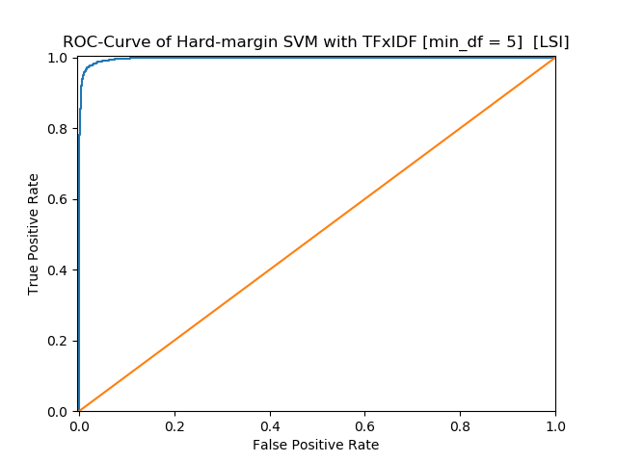

 | Precision | Recall | Accuracy
Computer technology | 0.9666 | 0.9827 | 0.9746
Recreational activity | 0.9827 | 0.9667 | 0.9746
Average | 0.9747 | 0.9747 | 0.9746

Confusion Matrix is as following (at Computer Technology row we treat Computer Technology as positive, vice versa):
 | TP | FP | FN | TN
Computer technology | 1533 | 53 | 27 | 1537
Recreational activity | 1537 | 27 | 53 | 1533

We set computer technology as positive and recreational activity as negative to construct the confusion matrix as follow:
 | Ground Truth | Ground False
Predicted positive | 1533 | 53
Predicted negative | 27 | 1537

- Hard-Margin SVM with NMF
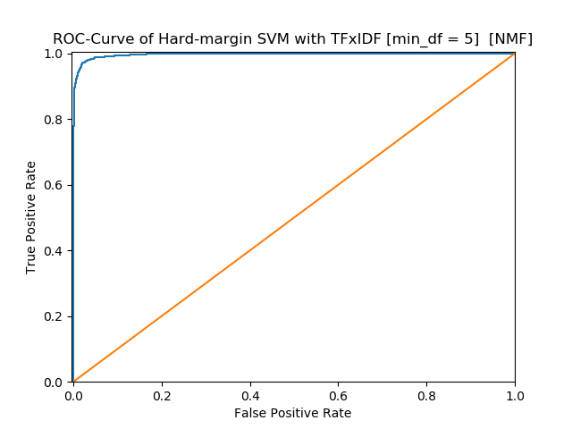

 | Precision | Recall | Accuracy
Computer technology | 0.9910 | 0.9173 | 0.9549
Recreational activity | 0.9244 | 0.9918 | 0.9549
Average | 0.9546 | 0.9577 | 0.9549

Confusion Matrix is as following (at Computer Technology row we treat Computer Technology as positive, vice versa):
 | TP | FP | FN | TN
Computer technology | 1431 | 13 | 129 | 1577
Recreational activity | 1577 | 129 | 13 | 1431
We set computer technology as positive and recreational activity as negative to construct the confusion matrix as follow:
 | Ground Truth | Ground False
Predicted positive | 1431 | 13
Predicted negative | 129 | 1577

- Soft-Margin SVM with LSI
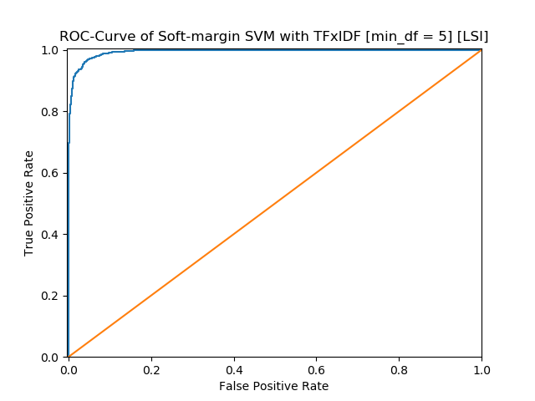

 | Precision | Recall | Accuracy
Computer technology | 0.9908 | 0.8981 | 0.9454
Recreational activity | 0.9084 | 0.9918 | 0.9454
Average | 0.9450 | 0.9496 | 0.9454

Confusion Matrix is as following (at Computer Technology row we treat Computer Technology as positive, vice versa):
 | TP | FP | FN | TN
Computer technology | 1401 | 13 | 159 | 1577
Recreational activity | 1577 | 159 | 13 | 1401
We set computer technology as positive and recreational activity as negative to construct the confusion matrix as follow:
 | Ground Truth | Ground False
Predicted positive | 1401 | 13
Predicted negative | 159 | 1577

- Soft-Margin SVM with NMF
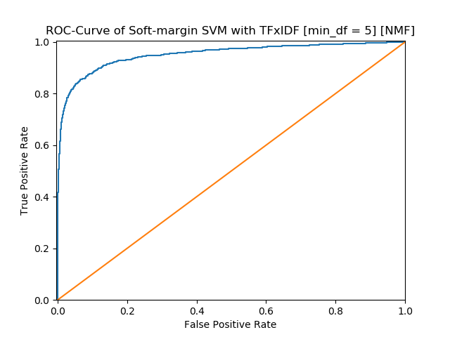

 | Precision | Recall | Accuracy
Computer technology | 0.9576 | 0.3910 | 0.6898
Recreational activity | 0.6220 | 0.9830 | 0.6898
Average | 0.6870 | 0.7898 | 0.6898

Confusion Matrix is as following (at Computer Technology row we treat Computer Technology as positive, vice versa):
 | TP | FP | FN | TN
Computer technology | 610 | 27 | 950 | 1563
Recreational activity | 1563 | 950 | 27 | 610
We set computer technology as positive and recreational activity as negative to construct the confusion matrix as follow:
 | Ground Truth | Ground False
Predicted positive | 610 | 27
Predicted negative | 950 | 1563
As we could see, in our model, when we choice min_df =5 , the model’s accuracy is better than the model for min_df = 2. As to each category, the LSI model is better than NMF and hard SVM is better than soft SVM.

Cross-validation to find the best γ
In this part, we use 5-fold cross-validation to find the parameter γ and report the confusion matrix and accuracy, recall and precision.
When Min_df=2

[gamma = 0.001] 5-Fold Average Accuracy: 0.94421304
[gamma = 0.01] 5-Fold Average Accuracy: 0.96745837
[gamma = 0.1] 5-Fold Average Accuracy: 0.96999537
[gamma = 1.0] 5-Fold Average Accuracy: 0.97591124
[gamma = 10] 5-Fold Average Accuracy: 0.97654459
[gamma = 100] 5-Fold Average Accuracy: 0.97569870
[gamma = 1000] 5-Fold Average Accuracy: 0.97379774

Best Accuracy is 0.97654459 when gamma = 10

SVM with TFxIDF [LSI] gamma = 10
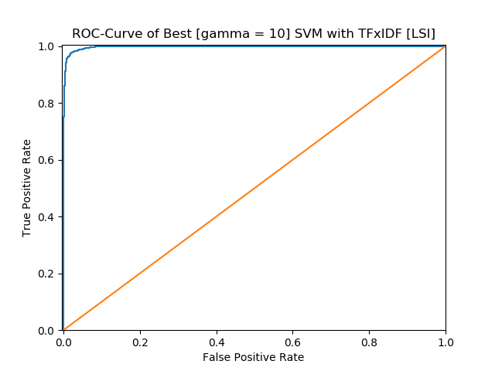

 | Precision | Recall | Accuracy
Computer technology | 0.9818 | 0.9679 | 0.9752
Recreational activity | 0.9690 | 0.9824 | 0.9752
Average | 0.9752 | 0.9754 | 0.9752

Confusion Matrix is as following (at Computer Technology row we treat Computer Technology as positive, vice versa):
 | TP | FP | FN | TN
Computer technology | 1510 | 28 | 50 | 1562
Recreational activity | 1562 | 50 | 28 | 1510

We set computer technology as positive and recreational activity as negative to construct the confusion matrix as follow:
 | Ground Truth | Ground False
Predicted positive | 1510 | 28
Predicted negative | 50 | 1562

SVM with TFxIDF [NMF] gamma = 10
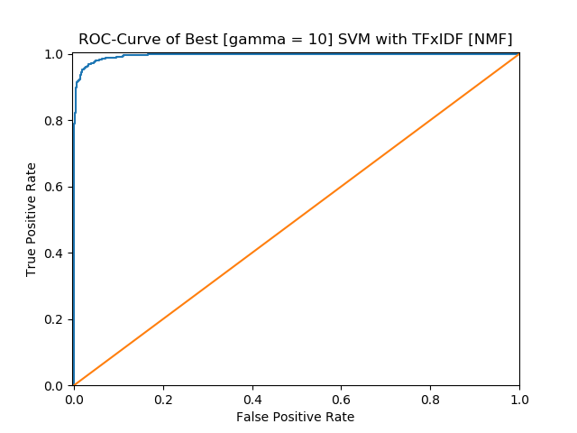

 | Precision | Recall | Accuracy
Computer technology | 0.9738 | 0.9538 | 0.9644
Recreational activity | 0.9556 | 0.9748 | 0.9644
Average | 0.9643 | 0.9647 | 0.9644

Confusion Matrix is as following (at Computer Technology row we treat Computer Technology as positive, vice versa):
 | TP | FP | FN | TN
Computer technology | 1488 | 40 | 72 | 1550
Recreational activity | 1550 | 72 | 40 | 1488

We set computer technology as positive and recreational activity as negative to construct the confusion matrix as follow:
 | Ground Truth | Ground False
Predicted positive | 1488 | 40
Predicted negative | 72 | 1550

When min_df = 5

[gamma = 0.001] 5-Fold Average Accuracy: 0.94695967
[gamma = 0.01] 5-Fold Average Accuracy: 0.96640173
[gamma = 0.1] 5-Fold Average Accuracy: 0.97020656
[gamma = 1.0] 5-Fold Average Accuracy: 0.97506535
[gamma = 10] 5-Fold Average Accuracy: 0.97612198
[gamma = 100] 5-Fold Average Accuracy: 0.97548840
[gamma = 1000] 5-Fold Average Accuracy: 0.95838086

Best Accuracy is 0.97612198 when gamma = 10

SVM with TFxIDF [LSI]
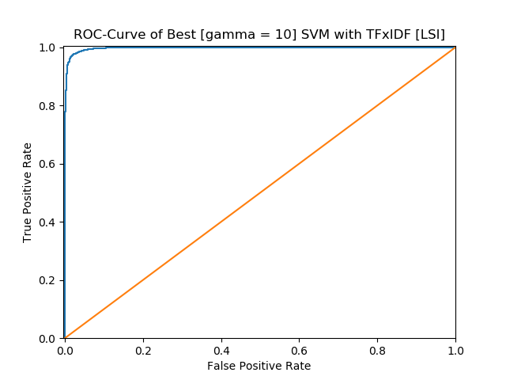

 | Precision | Recall | Accuracy
Computer technology | 0.9812 | 0.9679 | 0.9749
Recreational activity | 0.9690 | 0.9818 | 0.9749
Average | 0.9749 | 0.9751 | 0.9749

Confusion Matrix is as following (at Computer Technology row we treat Computer Technology as positive, vice versa):
 | TP | FP | FN | TN
Computer technology | 1510 | 29 | 50 | 1561
Recreational activity | 1561 | 50 | 29 | 1510

We set computer technology as positive and recreational activity as negative to construct the confusion matrix as follow:
 | Ground Truth | Ground False
Predicted positive | 1510 | 29
Predicted negative | 50 | 1561

SVM with TFxIDF [NMF]
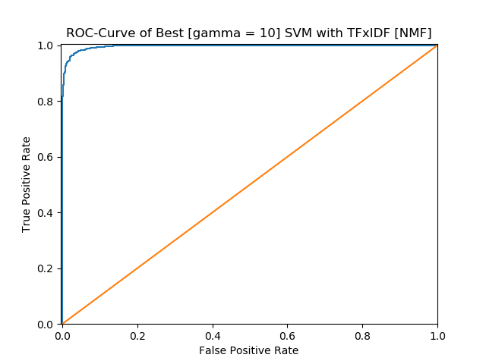

 | Precision | Recall | Accuracy
Computer technology | 0.9784 | 0.9564 | 0.9679
Recreational activity | 0.9582 | 0.9792 | 0.9679
Average | 0.9678 | 0.9683 | 0.9679

Confusion Matrix is as following (at Computer Technology row we treat Computer Technology as positive, vice versa):
 | TP | FP | FN | TN
Computer technology | 1492 | 33 | 68 | 1557
Recreational activity | 1557 | 68 | 33 | 1492

We set computer technology as positive and recreational activity as negative to construct the confusion matrix as follow:
 | Ground Truth | Ground False
Predicted positive | 1492 | 33
Predicted negative | 68 | 1557

As we could see, in our model, when we choice min_df =5 , the model’s accuracy is nearly equal to the model for min_df = 2. As to each category(min_df), the LSI model is a little better than NMF

Naïve Bayes algorithm
Next, we use naïve Bayes algorithm for the same classification task.
When min_df=2
Naïve Bayes with LSI
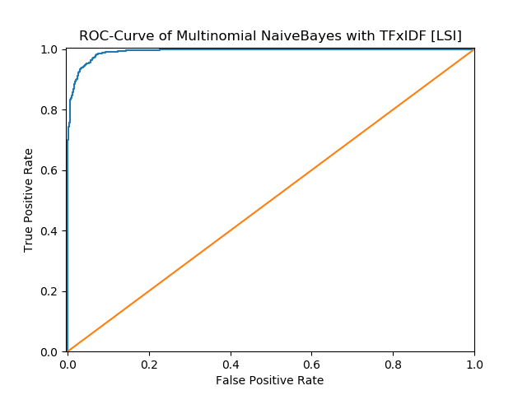

 | Precision | Recall | Accuracy
Computer technology | 0.9927 | 0.8718 | 0.9333
Recreational activity | 0.8876 | 0.9937 | 0.9333
Average | 0.9328 | 0.9402 | 0.9333
Confusion Matrix is as following (at Computer Technology row we treat Computer Technology as positive, vice versa):
 | TP | FP | FN | TN
Computer technology | 1360 | 10 | 200 | 1580
Recreational activity | 1580 | 200 | 10 | 1360
We set computer technology as positive and recreational activity as negative to construct the confusion matrix as follow:
 | Ground Truth | Ground False
Predicted positive | 1360 | 10
Predicted negative | 200 | 1580

Naïve Bayes with NMF
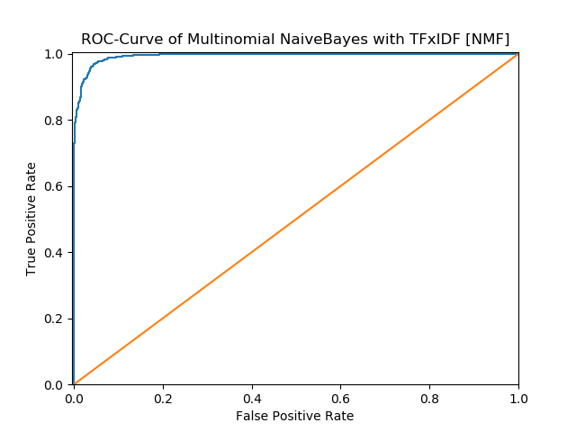

 | Precision | Recall | Accuracy
Computer technology | 0.9773 | 0.9397 | 0.9594
Recreational activity | 0.9430 | 0.9786 | 0.9594
Average | 0.9592 | 0.9602 | 0.9594
Confusion Matrix is as following (at Computer Technology row we treat Computer Technology as positive, vice versa):
 | TP | FP | FN | TN
Computer technology | 1466 | 34 | 94 | 1556
Recreational activity | 1556 | 94 | 34 | 1466
We set computer technology as positive and recreational activity as negative to construct the confusion matrix as follow:
 | Ground Truth | Ground False
Predicted positive | 1466 | 34
Predicted negative | 94 | 1556
Naïve Bayes with original TFxIDF

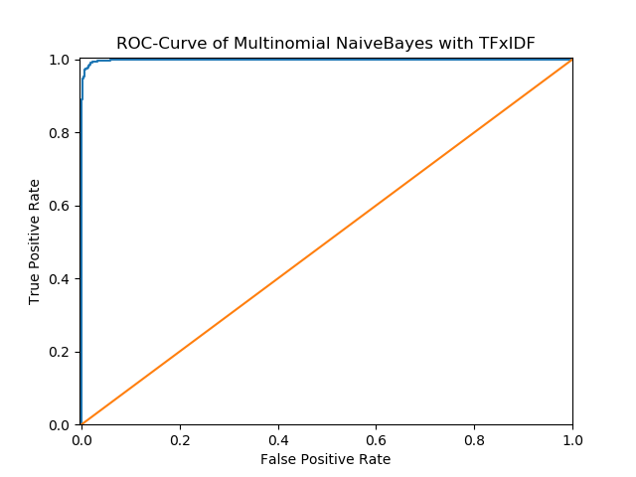

 | Precision | Recall | Accuracy
Computer technology | 0.9890 | 0.9814 | 0.9854
Recreational activity | 0.9819 | 0.9893 | 0.9854
Average | 0.9854 | 0.9855 | 0.9854
Confusion Matrix is as following (at Computer Technology row we treat Computer Technology as positive, vice versa):
 | TP | FP | FN | TN
Computer technology | 1531 | 17 | 29 | 1573
Recreational activity | 1573 | 29 | 17 | 1531

We set computer technology as positive and recreational activity as negative to construct the confusion matrix as follow:
 | Ground Truth | Ground False
Predicted positive | 1531 | 17
Predicted negative | 29 | 1573

When min_df=5
Naive Bayes with LSI
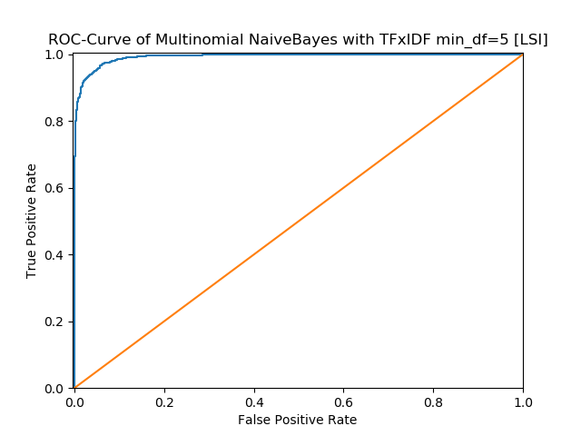

 | Precision | Recall | Accuracy
Computer technology | 0.9967 | 0.7686 | 0.8841
Recreational activity | 0.8146 | 0.9975 | 0.8841
Average | 0.8830 | 0.9056 | 0.8841
Confusion Matrix is as following (at Computer Technology row we treat Computer Technology as positive, vice versa):
 | TP | FP | FN | TN
Computer technology | 1199 | 4 | 361 | 1586
Recreational activity | 1586 | 361 | 4 | 1199
We set computer technology as positive and recreational activity as negative to construct the confusion matrix as follow:
 | Ground Truth | Ground False
Predicted positive | 1199 | 4
Predicted negative | 361 | 1586

Naïve Bayes with NMF
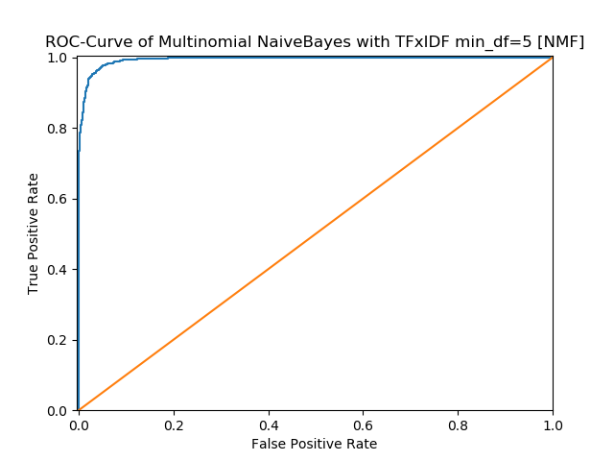

 | Precision | Recall | Accuracy
Computer technology | 0.9811 | 0.9333 | 0.9581
Recreational activity | 0.9376 | 0.9824 | 0.9581
Average | 0.9579 | 0.9594 | 0.9581
Confusion Matrix is as following (at Computer Technology row we treat Computer Technology as positive, vice versa):
 | TP | FP | FN | TN
Computer technology | 1456 | 28 | 104 | 1562
Recreational activity | 1562 | 104 | 28 | 1456
We set computer technology as positive and recreational activity as negative to construct the confusion matrix as follow:
 | Ground Truth | Ground False
Predicted positive | 1456 | 28
Predicted negative | 104 | 1562

Naïve Bayes with Original TFxIDF
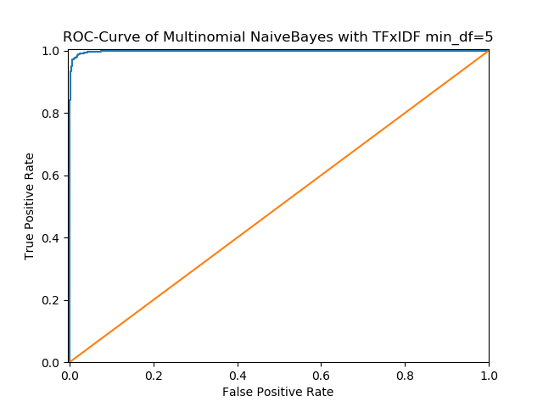

 | Precision | Recall | Accuracy
Computer technology | 0.9771 | 0.9840 | 0.9806
Recreational activity | 0.9842 | 0.9774 | 0.9806
Average | 0.9807 | 0.9806 | 0.9806
Confusion Matrix is as following (at Computer Technology row we treat Computer Technology as positive, vice versa):
 | TP | FP | FN | TN
Computer technology | 1535 | 36 | 25 | 1554
Recreational activity | 1554 | 25 | 36 | 1535
We set computer technology as positive and recreational activity as negative to construct the confusion matrix as follow:
 | Ground Truth | Ground False
Predicted positive | 1535 | 36
Predicted negative | 25 | 1554
As we could see, in Bayes model, when we choice min_df =2 , the model’s accuracy is better than the model for min_df = 5. As to each category(min_df), the NMF model is better than LSI model.

8.logistic regression classifier
When min_df=2
Logistic Regression with LSI when min_df = 2
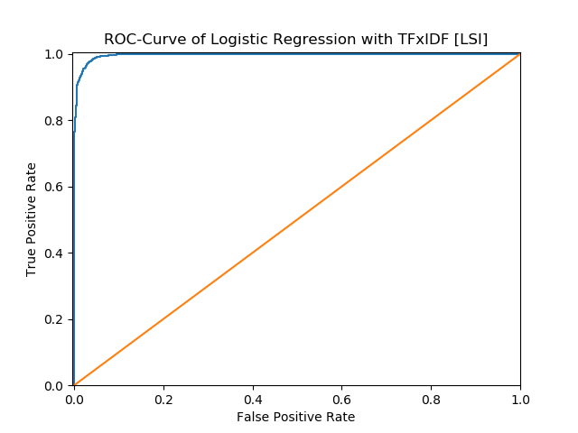

 | Precision | Recall | Accuracy
Computer technology | 0.9804 | 0.9603 | 0.9708
Recreational activity | 0.9618 | 0.9811 | 0.9708
Average | 0.9707 | 0.9711 | 0.9708
Confusion Matrix is as following (at Computer Technology row we treat Computer Technology as positive, vice versa):
 | TP | FP | FN | TN
Computer technology | 1498 | 30 | 62 | 1560
Recreational activity | 1560 | 62 | 30 | 1498
We set computer technology as positive and recreational activity as negative to construct the confusion matrix as follow:
 | Ground Truth | Ground False
Predicted positive | 1498 | 30
Predicted negative | 62 | 1560

Logistic Regression with NMF when min_df = 2
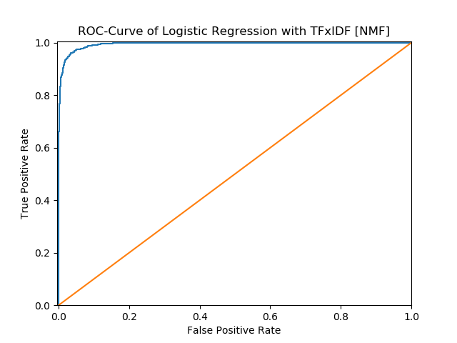

 | Precision | Recall | Accuracy
Computer technology | 0.9657 | 0.9551 | 0.9610
Recreational activity | 0.9564 | 0.9667 | 0.9610
Average | 0.9609 | 0.9610 | 0.9610
Confusion Matrix is as following (at Computer Technology row we treat Computer Technology as positive, vice versa):
 | TP | FP | FN | TN
Computer technology | 1490 | 53 | 70 | 1573
Recreational activity | 1537 | 70 | 53 | 1490
We set computer technology as positive and recreational activity as negative to construct the confusion matrix as follow:
 | Ground Truth | Ground False
Predicted positive | 1490 | 53
Predicted negative | 70 | 1537

When min_df=5
Logistic Regression with LSI when min_df = 5
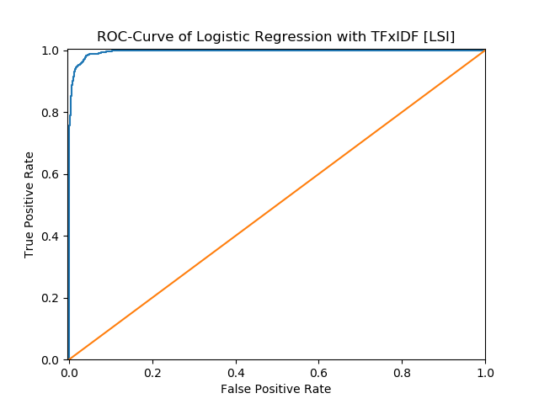

 | Precision | Recall | Accuracy
Computer technology | 0.9784 | 0.9596 | 0.9695
Recreational activity | 0.9611 | 0.9792 | 0.9695
Average | 0.9694 | 0.9698 | 0.9695
Confusion Matrix is as following (at Computer Technology row we treat Computer Technology as positive, vice versa):
 | TP | FP | FN | TN
Computer technology | 1497 | 33 | 63 | 1557
Recreational activity | 1557 | 63 | 33 | 1497
We set computer technology as positive and recreational activity as negative to construct the confusion matrix as follow:
 | Ground Truth | Ground False
Predicted positive | 1497 | 33
Predicted negative | 63 | 1557

Logistic Regression with NMF when min_df = 5
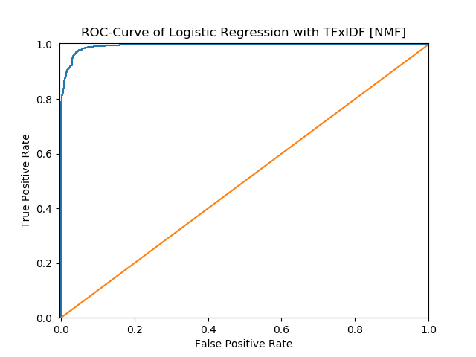

 | Precision | Recall | Accuracy
Computer technology | 0.9683 | 0.9603 | 0.9648
Recreational activity | 0.9613 | 0.9692 | 0.9648
Average | 0.9647 | 0.9648 | 0.9648
Confusion Matrix is as following (at Computer Technology row we treat Computer Technology as positive, vice versa):
 | TP | FP | FN | TN
Computer technology | 1498 | 49 | 62 | 1541
Recreational activity | 1541 | 62 | 49 | 1498
We set computer technology as positive and recreational activity as negative to construct the confusion matrix as follow:
 | Ground Truth | Ground False
Predicted positive | 1498 | 49
Predicted negative | 62 | 1541
As we could see, in our model, when we choice min_df =2 , the model’s accuracy is better than the model for min_df = 5. As to each category, the LSI model is better than NMF .

9. Optimize model
Now, by adding a regularization term to the optimization objective. We try both L1 and L2 norm regularizations and sweep through different regularization coefficients, ranging from very small ones to large ones.
C from the 0.001 to 10, and we choice the best score to output
L1-Logistic Regression with LSI when min_df = 2
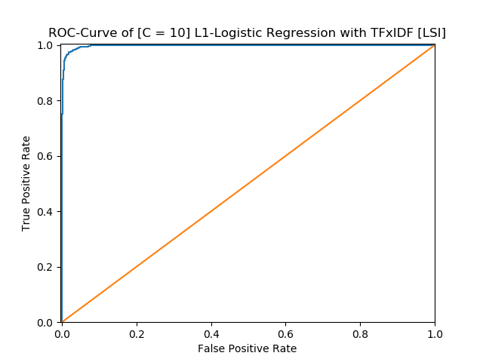

 | Precision | Recall | Accuracy
Computer technology | 0.9817 | 0.9654 | 0.9740
Recreational activity | 0.9666 | 0.9824 | 0.9740
Average | 0.9739 | 0.9742 | 0.9740
Confusion Matrix is as following (at Computer Technology row we treat Computer Technology as positive, vice versa):
 | TP | FP | FN | TN
Computer technology | 1506 | 28 | 54 | 1562
Recreational activity | 1562 | 54 | 28 | 1506
We set computer technology as positive and recreational activity as negative to construct the confusion matrix as follow:
 | Ground Truth | Ground False
Predicted positive | 1562 | 28
Predicted negative | 54 | 1562

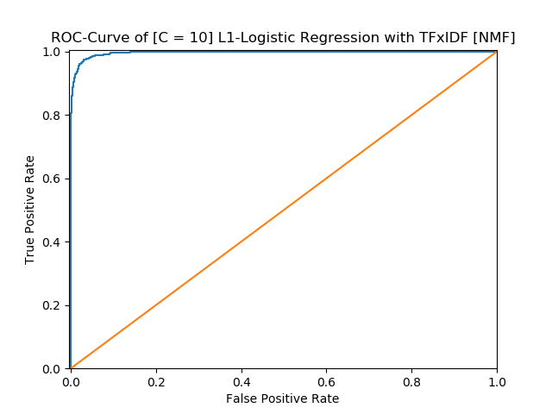
L1 Logistic Regression with NMF when min_df = 2

 | Precision | Recall | Accuracy
Computer technology | 0.9790 | 0.9551 | 0.9676
Recreational activity | 0.9570 | 0.9799 | 0.9676
Average | 0.9675 | 0.9680 | 0.9676
Confusion Matrix is as following (at Computer Technology row we treat Computer Technology as positive, vice versa):
 | TP | FP | FN | TN
Computer technology | 1490 | 32 | 70 | 1558
Recreational activity | 1558 | 70 | 32 | 1490
We set computer technology as positive and recreational activity as negative to construct the confusion matrix as follow:
 | Ground Truth | Ground False
Predicted positive | 1490 | 32
Predicted negative | 70 | 1558

L2 Logistic Regression with LSI when min_df = 2
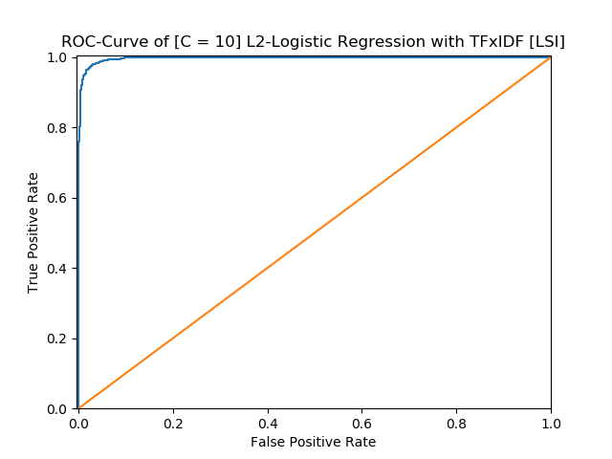

 | Precision | Recall | Accuracy
Computer technology | 0.9817 | 0.9635 | 0.9730
Recreational activity | 0.9648 | 0.9824 | 0.9730
Average | 0.9729 | 0.9733 | 0.9730
Confusion Matrix is as following (at Computer Technology row we treat Computer Technology as positive, vice versa):
 | TP | FP | FN | TN
Computer technology | 1503 | 28 | 57 | 1562
Recreational activity | 1562 | 57 | 28 | 1503
We set computer technology as positive and recreational activity as negative to construct the confusion matrix as follow:
 | Ground Truth | Ground False
Predicted positive | 1503 | 28
Predicted negative | 57 | 1562

L2 Logistic Regression with NMF when min_df = 2
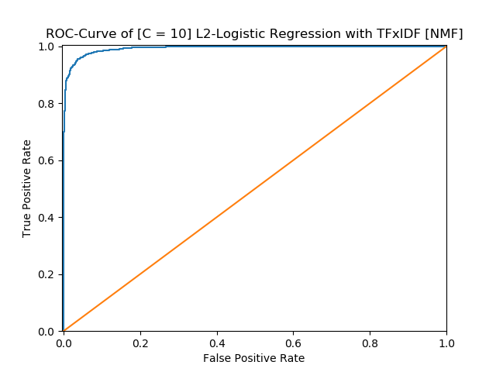

 | Precision | Recall | Accuracy
Computer technology | 0.9659 | 0.9455 | 0.9565
Recreational activity | 0.9476 | 0.9673 | 0.9565
Average | 0.9564 | 0.9568 | 0.9565
Confusion Matrix is as following (at Computer Technology row we treat Computer Technology as positive, vice versa):
 | TP | FP | FN | TN
Computer technology | 1475 | 52 | 85 | 1538
Recreational activity | 1538 | 85 | 52 | 1475
We set computer technology as positive and recreational activity as negative to construct the confusion matrix as follow:
 | Ground Truth | Ground False
Predicted positive | 1475 | 52
Predicted negative | 85 | 1538

When min_df=5
L1 Logistic Regression with LSI min_df = 5
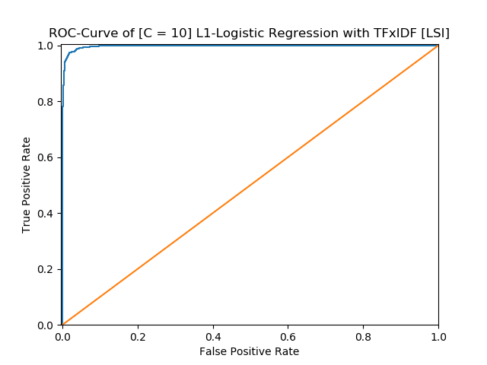

 | Precision | Recall | Accuracy
Computer technology | 0.9798 | 0.9654 | 0.9730
Recreational activity | 0.9665 | 0.9805 | 0.9730
Average | 0.9729 | 0.9732 | 0.9730
Confusion Matrix is as following (at Computer Technology row we treat Computer Technology as positive, vice versa):
 | TP | FP | FN | TN
Computer technology | 1506 | 31 | 54 | 1559
Recreational activity | 1559 | 54 | 31 | 1506
We set computer technology as positive and recreational activity as negative to construct the confusion matrix as follow:
 | Ground Truth | Ground False
Predicted positive | 1506 | 31
Predicted negative | 54 | 1559

L1 Logistic Regression with NMF when min_df = 5
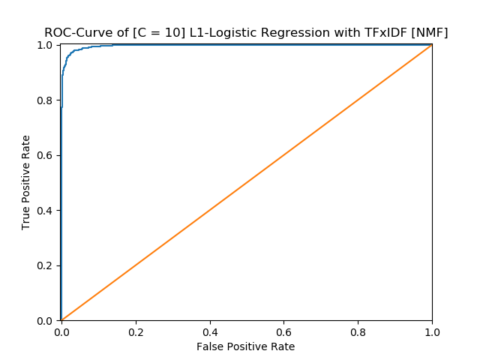

 | Precision | Recall | Accuracy
Computer technology | 0.9810 | 0.9603 | 0.9711
Recreational activity | 0.9618 | 0.9818 | 0.9711
Average | 0.9710 | 0.9714 | 0.9711
Confusion Matrix is as following (at Computer Technology row we treat Computer Technology as positive, vice versa):
 | TP | FP | FN | TN
Computer technology | 1498 | 29 | 62 | 1561
Recreational activity | 1561 | 62 | 29 | 1498

We set computer technology as positive and recreational activity as negative to construct the confusion matrix as follow:
 | Ground Truth | Ground False
Predicted positive | 1498 | 29
Predicted negative | 62 | 1561

L2 Logistic regression with LSI when min_df = 5
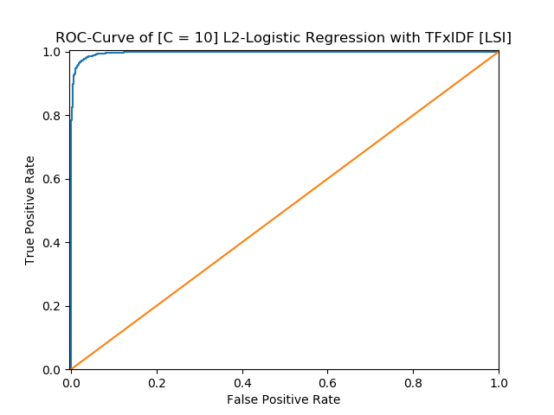

 | Precision | Recall | Accuracy
Computer technology | 0.9811 | 0.9647 | 0.9733
Recreational activity | 0.9660 | 0.9818 | 0.9733
Average | 0.9733 | 0.9735 | 0.9733
Confusion Matrix is as following (at Computer Technology row we treat Computer Technology as positive, vice versa):
 | TP | FP | FN | TN
Computer technology | 1505 | 29 | 55 | 1561
Recreational activity | 1561 | 55 | 29 | 1505
We set computer technology as positive and recreational activity as negative to construct the confusion matrix as follow:
 | Ground Truth | Ground False
Predicted positive | 1505 | 29
Predicted negative | 55 | 1561

L2 Logistic regression with NMF when min_df = 5
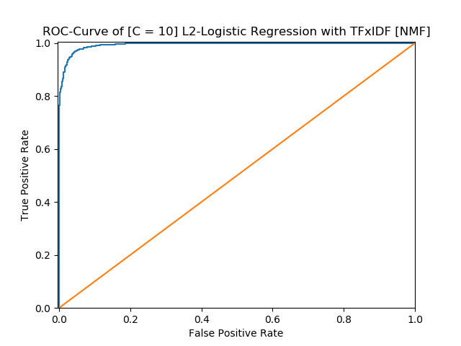

 | Precision | Recall | Accuracy
Computer technology | 0.9711 | 0.9487 | 0.9606
Recreational activity | 0.9508 | 0.9732 | 0.9606
Average | 0.9605 | 0.9610 | 0.9606
Confusion Matrix is as following (at Computer Technology row we treat Computer Technology as positive, vice versa):
 | TP | FP | FN | TN
Computer technology | 1480 | 44 | 80 | 1546
Recreational activity | 1546 | 80 | 44 | 1480
We set computer technology as positive and recreational activity as negative to construct the confusion matrix as follow:
 | Ground Truth | Ground False
Predicted positive | 1480 | 44
Predicted negative | 80 | 1546

In summary, l1 norm and l2 norm can get similar best accuracy and there is not a fixed best combination of parameters. No matter which regularization method we use, smaller C tends to perform worse. Parameter ‘min_df = 2’ tend to get better results than ‘min_df = 5’ in most classifiers, especially the number of true positive and true negative. It is probably because ‘min_df = 5’ removes so much information from the documents. And, LSI method is a little better than NMF.

Multi-class Classification
In this part, we aim to perform Naïve Bayes classification and multiclass SVM classification (with both One VS One and One VS the rest methods described above) and report the confusion matrix and calculate the accuracy, recall and precision of your classifiers

Multinomial NaiveBayes with TFIDF when min_df is 2 [LSI]
 | Precision | Recall | Accuracy
comp.sys.ibm.pc.hardware | 0.7717 | 0.6811 | 0.8696
comp.sys.mac.hardware | 0.8177 | 0.7688 | 0.9010
misc.forsale | 0.7131 | 0.8667 | 0.8799
soc.religion.christian | 0.9765 | 0.9397 | 0.9789
Average | 0.8141 | 0.8197 | 0.9073
Confusion Matrix is as following (at comp.sys.ibm.pc.hardware row we treat Computer Technology as positive, vice versa):
 | TP | FP | FN | TN
comp.sys.ibm.pc.hardware | 267 | 79 | 125 | 1094
comp.sys.mac.hardware | 296 | 66 | 89 | 1114
misc.forsale | 338 | 136 | 52 | 1039
soc.religion.christian | 374 | 9 | 24 | 1158
We set comp.sys.ibm.pc.hardware as positive and others as negative to construct the confusion matrix as follow:
 | Ground Truth | Ground False
Predicted positive | 267 | 79
Predicted negative | 125 | 1094

Multinomial NaiveBayes with TFIDF when min_df is 2 [NMF]
 | Precision | Recall | Accuracy
comp.sys.ibm.pc.hardware | 0.8054 | 0.7602 | 0.8939
comp.sys.mac.hardware | 0.8226 | 0.7948 | 0.9073
misc.forsale | 0.8000 | 0.8615 | 0.9118
soc.religion.christian | 0.9752 | 0.9874 | 0.9904
Average | 0.8510 | 0.8508 | 0.9259
Confusion Matrix is as following (at comp.sys.ibm.pc.hardware row we treat Computer Technology as positive, vice versa):
 | TP | FP | FN | TN
comp.sys.ibm.pc.hardware | 298 | 72 | 94 | 1101
comp.sys.mac.hardware | 306 | 66 | 79 | 1114
misc.forsale | 336 | 84 | 54 | 1091
soc.religion.christian | 393 | 10 | 5 | 1157
We set comp.sys.ibm.pc.hardware as positive and others as negative to construct the confusion matrix as follow:
 | Ground Truth | Ground False
Predicted positive | 336 | 84
Predicted negative | 54 | 1091

Multinomial NaiveBayes with TFIDF when min_df is 5 [LSI]
 | Precision | Recall | Accuracy
comp.sys.ibm.pc.hardware | 0.7237 | 0.8087 | 0.8748
comp.sys.mac.hardware | 0.9022 | 0.6468 | 0.8958
misc.forsale | 0.8739 | 0.7821 | 0.9176
soc.religion.christian | 0.7928 | 1.0000 | 0.9335
Average | 0.8094 | 0.8232 | 0.9054

Confusion Matrix is as following (at comp.sys.ibm.pc.hardware row we treat Computer Technology as positive, vice versa):
 | TP | FP | FN | TN
comp.sys.ibm.pc.hardware | 317 | 121 | 75 | 1052
comp.sys.mac.hardware | 249 | 27 | 136 | 1153
misc.forsale | 305 | 44 | 85 | 1131
soc.religion.christian | 398 | 104 | 0 | 1063
We set comp.sys.ibm.pc.hardware as positive and others as negative to construct the confusion matrix as follow:
 | Ground Truth | Ground False
Predicted positive | 317 | 121
Predicted negative | 75 | 1052

Multinomial NaiveBayes with TFIDF when min_df is 5 [NMF]
 | Precision | Recall | Accuracy
comp.sys.ibm.pc.hardware | 0.7558 | 0.7500 | 0.8767
comp.sys.mac.hardware | 0.7836 | 0.7714 | 0.8914
misc.forsale | 0.8321 | 0.8513 | 0.9201
soc.religion.christian | 0.9824 | 0.9824 | 0.9911
Average | 0.8388 | 0.8385 | 0.9198
Confusion Matrix is as following (at comp.sys.ibm.pc.hardware row we treat Computer Technology as positive, vice versa):
 | TP | FP | FN | TN
comp.sys.ibm.pc.hardware | 294 | 95 | 98 | 1078
comp.sys.mac.hardware | 297 | 82 | 88 | 1198
misc.forsale | 332 | 67 | 58 | 1108
soc.religion.christian | 391 | 7 | 7 | 1160
We set comp.sys.ibm.pc.hardware as positive and others as negative to construct the confusion matrix as follow:
 | Ground Truth | Ground False
Predicted positive | 294 | 95
Predicted negative | 98 | 1078

Multi-calss SVM ovo with TFIDF when min_df is 5 [LSI]
 | Precision | Recall | Accuracy
comp.sys.ibm.pc.hardware | 0.7815 | 0.8393 | 0.8748
comp.sys.mac.hardware | 0.8497 | 0.8078 | 0.9010
misc.forsale | 0.9415 | 0.7846 | 0.9342
soc.religion.christian | 0.8764 | 0.9975 | 0.9636
Average | 0.8573 | 0.8623 | 0.9291
Confusion Matrix is as following (at comp.sys.ibm.pc.hardware row we treat Computer Technology as positive, vice versa):
 | TP | FP | FN | TN
comp.sys.ibm.pc.hardware | 329 | 92 | 63 | 1081
comp.sys.mac.hardware | 311 | 55 | 74 | 1125
misc.forsale | 306 | 19 | 84 | 1156
soc.religion.christian | 397 | 56 | 1 | 1111
We set comp.sys.ibm.pc.hardware as positive and others as negative to construct the confusion matrix as follow:
 | Ground Truth | Ground False
Predicted positive | 329 | 92
Predicted negative | 63 | 1081

Multy SVM ovo with TFIDF when min_df is 5 [NMF]
 | Precision | Recall | Accuracy
comp.sys.ibm.pc.hardware | 0.5883 | 0.9005 | 0.8173
comp.sys.mac.hardware | 0.8517 | 0.6416 | 0.8843
misc.forsale | 0.9649 | 0.7051 | 0.9201
soc.religion.christian | 0.9769 | 0.9573 | 0.9834
Average | 0.8011 | 0.8455 | 0.9013
Confusion Matrix is as following (at comp.sys.ibm.pc.hardware row we treat Computer Technology as positive, vice versa):
 | TP | FP | FN | TN
comp.sys.ibm.pc.hardware | 353 | 247 | 39 | 926
comp.sys.mac.hardware | 247 | 43 | 138 | 1137
misc.forsale | 275 | 10 | 115 | 1165
soc.religion.christian | 381 | 9 | 17 | 1158
We set comp.sys.ibm.pc.hardware as positive and others as negative to construct the confusion matrix as follow:
 | Ground Truth | Ground False
Predicted positive | 353 | 247
Predicted negative | 39 | 926

Multi-class SVM ovr with TFIDF when min_df is 5 [LSI]
 | Precision | Recall | Accuracy
comp.sys.ibm.pc.hardware | 0.7815 | 0.8393 | 0.9010
comp.sys.mac.hardware | 0.8497 | 0.8078 | 0.9176
misc.forsale | 0.9415 | 0.7846 | 0.9342
soc.religion.christian | 0.8764 | 0.9975 | 0.9636
Average | 0.8573 | 0.8623 | 0.9291
Confusion Matrix is as following (at comp.sys.ibm.pc.hardware row we treat Computer Technology as positive, vice versa):
 | TP | FP | FN | TN
comp.sys.ibm.pc.hardware | 329 | 92 | 63 | 1081
comp.sys.mac.hardware | 311 | 55 | 74 | 1125
misc.forsale | 306 | 19 | 84 | 1156
soc.religion.christian | 397 | 56 | 1 | 1111
We set comp.sys.ibm.pc.hardware as positive and others as negative to construct the confusion matrix as follow:
 | Ground Truth | Ground False
Predicted positive | 329 | 92
Predicted negative | 63 | 1081

Multi-class SVM ovr with TFIDF when min_df is 5 [NMF]
 | Precision | Recall | Accuracy
comp.sys.ibm.pc.hardware | 0.5883 | 0.9005 | 0.8173
comp.sys.mac.hardware | 0.8517 | 0.6416 | 0.8843
misc.forsale | 0.9649 | 0.7051 | 0.9201
soc.religion.christian | 0.9769 | 0.9573 | 0.9834
Average | 0.8011 | 0.8455 | 0.9013
Confusion Matrix is as following (at comp.sys.ibm.pc.hardware row we treat Computer Technology as positive, vice versa):
 | TP | FP | FN | TN
comp.sys.ibm.pc.hardware | 353 | 247 | 39 | 926
comp.sys.mac.hardware | 247 | 43 | 138 | 1137
misc.forsale | 275 | 10 | 115 | 1165
soc.religion.christian | 381 | 9 | 17 | 1158
We set comp.sys.ibm.pc.hardware as positive and others as negative to construct the confusion matrix as follow:
 | Ground Truth | Ground False
Predicted positive | 353 | 247
Predicted negative | 39 | 926

Multi-class SVM ovo with TFIDF when min_df is 2 [LSI]
 | Precision | Recall | Accuracy
comp.sys.ibm.pc.hardware | 0.8686 | 0.6071 | 0.8786
comp.sys.mac.hardware | 0.7445 | 0.8857 | 0.8971
misc.forsale | 0.7773 | 0.8949 | 0.9099
soc.religion.christian | 0.9870 | 0.9523 | 0.9847
Average | 0.8350 | 0.8444 | 0.9176
Confusion Matrix is as following (at comp.sys.ibm.pc.hardware row we treat Computer Technology as positive, vice versa):
 | TP | FP | FN | TN
comp.sys.ibm.pc.hardware | 238 | 36 | 154 | 1137
comp.sys.mac.hardware | 341 | 117 | 44 | 1063
misc.forsale | 349 | 100 | 41 | 1075
soc.religion.christian | 379 | 5 | 19 | 1162
We set comp.sys.ibm.pc.hardware as positive and others as negative to construct the confusion matrix as follow:
 | Ground Truth | Ground False
Predicted positive | 238 | 36
Predicted negative | 154 | 1137

Multi-class SVM ovo with TFIDF when min_df is 2 [NMF]
 | Precision | Recall | Accuracy
comp.sys.ibm.pc.hardware | 0.6313 | 0.8954 | 0.8428
comp.sys.mac.hardware | 0.8338 | 0.7039 | 0.8927
misc.forsale | 0.9630 | 0.7333 | 0.9265
soc.religion.christian | 0.9897 | 0.9623 | 0.9879
Average | 0.8237 | 0.8544 | 0.9125
Confusion Matrix is as following (at comp.sys.ibm.pc.hardware row we treat Computer Technology as positive, vice versa):
 | TP | FP | FN | TN
comp.sys.ibm.pc.hardware | 351 | 205 | 41 | 968
comp.sys.mac.hardware | 271 | 54 | 114 | 1126
misc.forsale | 286 | 11 | 104 | 1164
soc.religion.christian | 383 | 4 | 15 | 1163
We set comp.sys.ibm.pc.hardware as positive and others as negative to construct the confusion matrix as follow:
 | Ground Truth | Ground False
Predicted positive | 351 | 205
Predicted negative | 41 | 968

Multi-class SVM ovr with TFIDF when min_df is 2 [LSI]
 | Precision | Recall | Accuracy
comp.sys.ibm.pc.hardware | 0.8686 | 0.6071 | 0.8786
comp.sys.mac.hardware | 0.7445 | 0.8857 | 0.8971
misc.forsale | 0.7773 | 0.8949 | 0.9099
soc.religion.christian | 0.9870 | 0.9523 | 0.9847
Average | 0.8350 | 0.8444 | 0.9176
Confusion Matrix is as following (at comp.sys.ibm.pc.hardware row we treat Computer Technology as positive, vice versa):
 | TP | FP | FN | TN
comp.sys.ibm.pc.hardware | 238 | 36 | 154 | 1137
comp.sys.mac.hardware | 341 | 117 | 44 | 1063
misc.forsale | 349 | 100 | 41 | 1075
soc.religion.christian | 379 | 5 | 19 | 1162

We set comp.sys.ibm.pc.hardware as positive and others as negative to construct the confusion matrix as follow:
 | Ground Truth | Ground False
Predicted positive | 238 | 36
Predicted negative | 154 | 1137

Multi-class SVM ovr with TFIDF when min_df is 2 [NMF]
 | Precision | Recall | Accuracy
comp.sys.ibm.pc.hardware | 0.6313 | 0.8954 | 0.8428
comp.sys.mac.hardware | 0.8338 | 0.7039 | 0.8927
misc.forsale | 0.9630 | 0.7333 | 0.9265
soc.religion.christian | 0.9897 | 0.9623 | 0.9879
Average | 0.8237 | 0.8544 | 0.9125
Confusion Matrix is as following (at comp.sys.ibm.pc.hardware row we treat Computer Technology as positive, vice versa):
 | TP | FP | FN | TN
comp.sys.ibm.pc.hardware | 351 | 205 | 41 | 968
comp.sys.mac.hardware | 271 | 54 | 114 | 1126
misc.forsale | 286 | 11 | 104 | 1164
soc.religion.christian | 383 | 4 | 15 | 1163

We set comp.sys.ibm.pc.hardware as positive and others as negative to construct the confusion matrix as follow:
 | Ground Truth | Ground False
Predicted positive | 351 | 205
Predicted negative | 41 | 968
In conclusion, generally in multiclass classification tasks, SVM (both “One VS One” and “One VS Rest”) perform better than Naïve Bayes. Comparing two SVM multiclass classification methods, “One VS Rest” runs faster than “One VS One” and gets a better result according to accuracy, precision and recall.

